PROGRESS REPORT ON MECHANISED MAINTENANCE OF KOMOLO - ABARILELA – AKORE ROAD
PROJECT DETAILS
PROJECT: MECHANISED MAINTENANCE OF KOMOLO – ABARILELA – AKORE ROAD
ROAD LENGTH: 20KM (KOMOLO -ABARILELA – OPUUSAI, AMURIA SECTION)
PLANNED ROAD LENGTH: 8KM
PLANNED DURATION: 33 DAYS
PROCUREMENT MECHANISM: FORCE ACCOUNT
FUNDER: GOVERNMENT OF UGANDA (UGANDA ROAD FUND FY 2018/19)

BACKGORUND
Komolo – Abarilela – Akore road is one of the District road network in Amuria. The entire road section is approximately 27km but the section now under Amuria District is about 20km.
The road traverses through Amolo P/S, Ongutoi H/C, Abarilela trading Centre, Akamurei P/S to Akore Townborad.
The road is both gravel and earth surface that has now deteriorated with numerous defects on the carriage way.
The District Council having scrutinized the development projects of FY 2018/19 allocated SHs. 55 million to maintain Komolo – Abarilela – Akore road.
The department latter allocated this project to be executed in the second quarter of FY2018/19.

PROGRESS
Actual physical works that are planned include bush clearing, heavy grading, spot gravelling and drainage works. Environmental aspects are also considered where some few trees will be planted in the institutions along the project. Borrow pits shall also be reinstated including existing once along the road.
Works commenced on the 6th November, 2018 and are expected to last 33 days.

SELECTED PICTURES
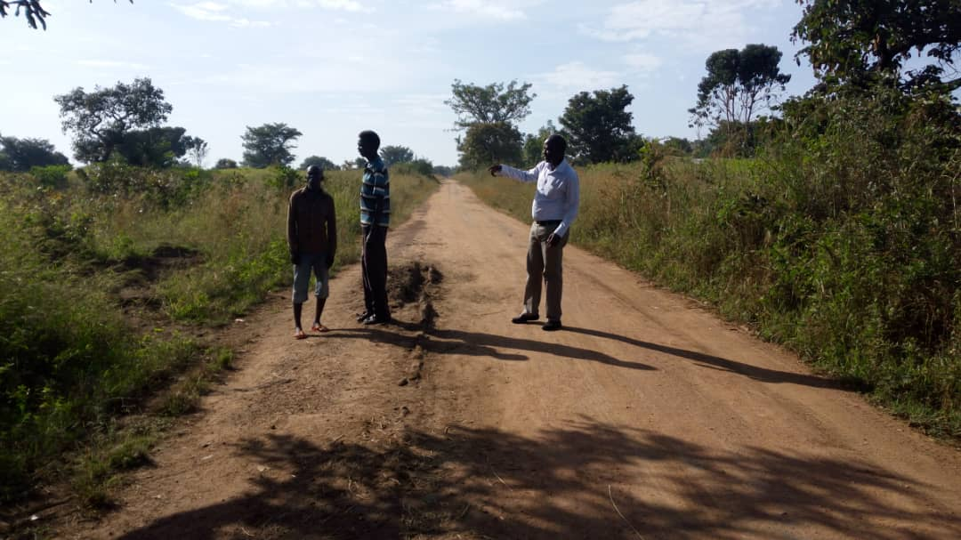
Road Section at Opuusai during assessment
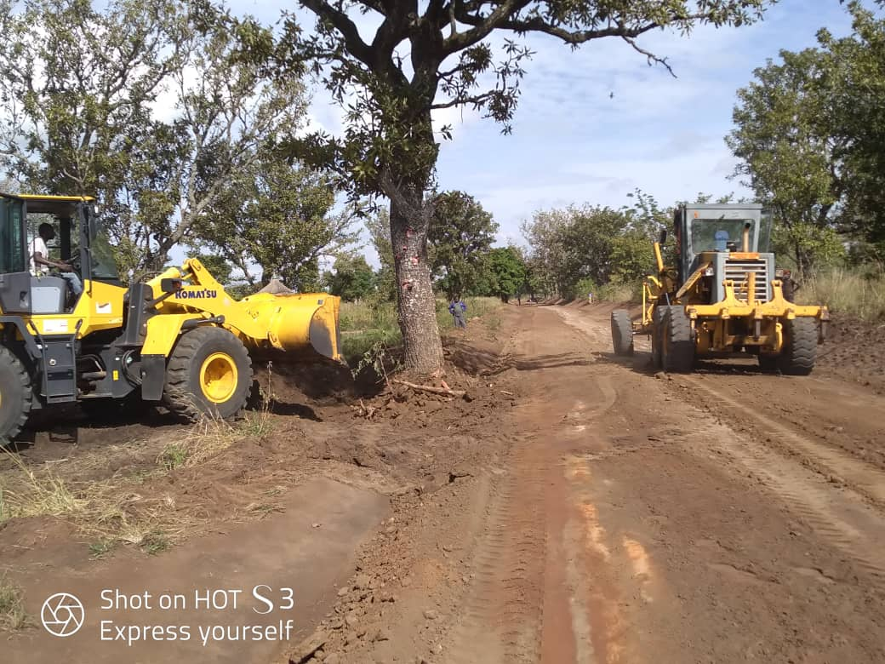
Widening of the carriage way

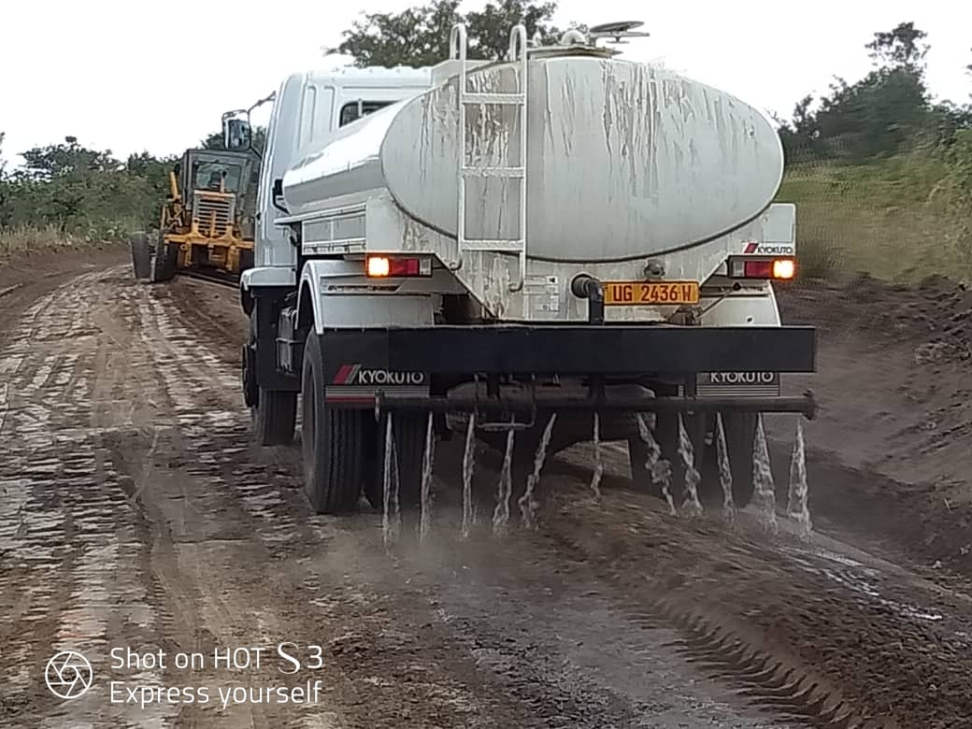
Watering during grading
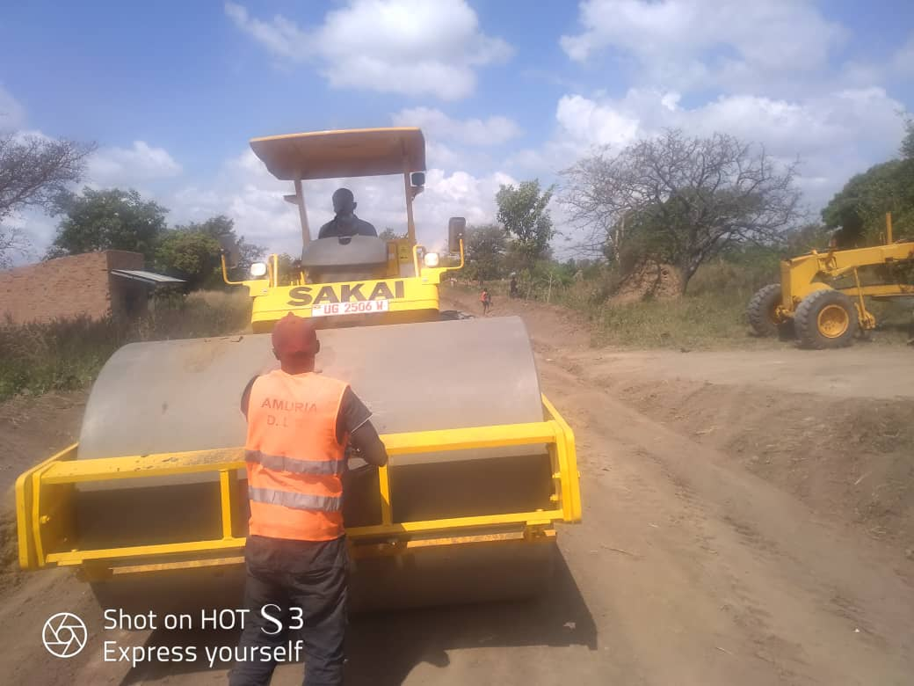
Compaction after grading
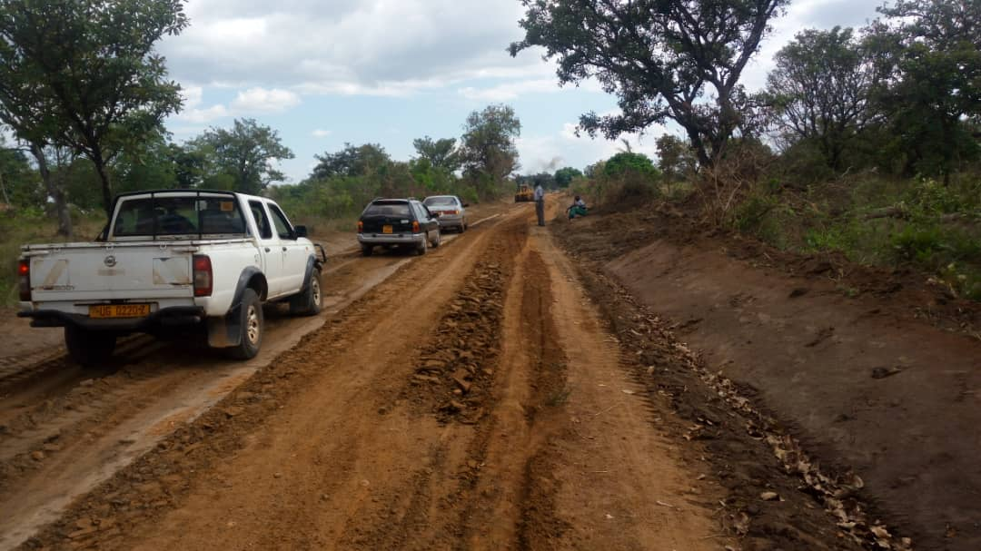
Supervision of ongoing works
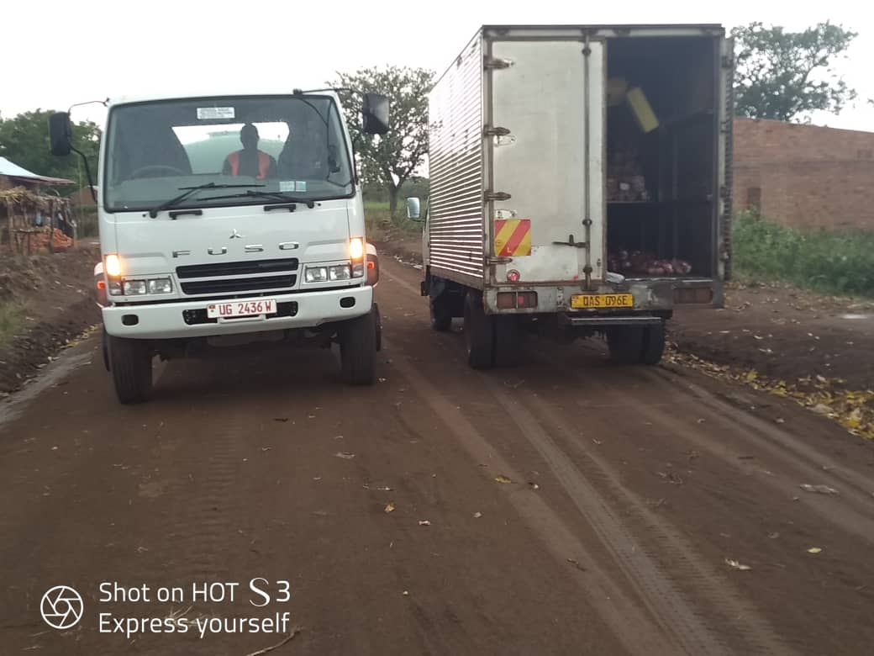
Complete section awaiting graveling

CHALLENGES
- Breakdown of motor grader equipment
- Heavy Rains that disrupted planned daily output

